# Week #7/Submission-3

**Week 7 - Cisco Packet Tracer 2 - Life of a Packet in Internet.**

**SRN : PES2UG20CS237**

**Name : P K Navin Shrinivas**

**Section : D**

## Task 1 : DNS Server and Webserver in the same netowork

## The needed topology was created as shown in screenshots.

## IP address and DNS server address was entered manually as seen below.

* **The DNS values were manually filled to maps IP addr to domain name**

## Using browser from pc, the website was fetched using URL follwing a successful DNS lookup.

## The successful status can be seen by the index.html page being loaded.

**Configurations followed :**

**End systems :**

|  |  |  |  |
| --- | --- | --- | --- |
| **End System** | **IP Address** | **Subnet Mask** | **DNS Server** |
| PC0 | 192.168.1.10 | 255.255.255.0 | 192.168.1.2 |
| Server2-DNS | 192.168.1.2 | 255.255.255.0 | 0.0.0.0 |
| Server3-Web server | 192.168.1.3 | 255.255.255.0 | 192.168.1.3 |

**DNS Service :**

|  |  |  |  |
| --- | --- | --- | --- |
| **No.** | **Name** | **Type** | **Detail** |
| 0 | www.dnslookup.com | A Record | 192.168.1.3 |

**Screenshots :**

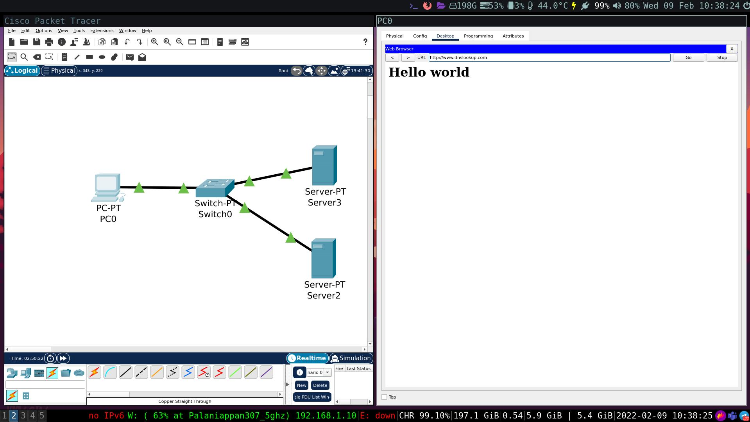

## **Task 2 : DNS Sever and Web Server across diff netoworks**

## The needed topology was created as shwon in screenshots.

## IP address, gateways, routing, DNS Server was entered manually as shown below.

* **DNS service was entered manually as shown below to map IP Addr to domain**

## A request was made to domain name using the browser in PC0

## The successful status can be seen by the loaded page, and the simulation panel.

**Configuration followed :**

**End systems :**

|  |  |  |  |  |
| --- | --- | --- | --- | --- |
| **End System** | **IP Address** | **Subnet Mask** | **Default Gateway** | **DNS Server** |
| PC0 | 192.168.1.2 | 255.255.255.0 | 192.168.1.1 | 192.168.3.2 |
| web server | 192.168.2.2 | 255.255.255.0 | 192.168.2.1 | 192.168.3.2 |
| DNS server | 192.168.3.2 | 255.255.255.0 | 192.168.3.1 | 0.0.0.0 |

**Routers :**

|  |  |  |  |
| --- | --- | --- | --- |
| **Router** | **Interface** | **IP address** | **Subnet Mask** |
| Router2 | GigabitEthernet0/0/0 | 192.168.1.1 | 255.255.255.0 |
| Router2 | Serial 0/2/0 | 10.0.2.1 | 255.0.0.0 |
| Router3 | GigabitEthernet0/0/0 | 192.168.2.1 | 255.255.255.0 |
| Router3 | GigabitEthernet0/0/1 | 192.168.3.1 | 255.255.255.0 |
| Router3 | Serial 0/1/0 | 10.0.2.2 | 255.0.0.0 |

**DNS Service :**

|  |  |  |  |
| --- | --- | --- | --- |
| **No.** | **Name** | **Type** | **Detail** |
| 0 | www.google.com | A Record | 192.168.2.2 |

**Routing Table :**

|  |  |  |
| --- | --- | --- |
| **Router** | **Destination** | **Next Hop** |
| Router2 | 192.168.3.0 | 10.0.2.2 |
| Router2 | 192.168.2.0 | 10.0.2.2 |
| Router3 | 192.168.1.0 | 10.0.2.1 |

## **Screenshots :**

